 | Music in real time  a miasma of post-pubescent pop, jazz/jam fusion, and microtonal rock staining the fabric of mass culture

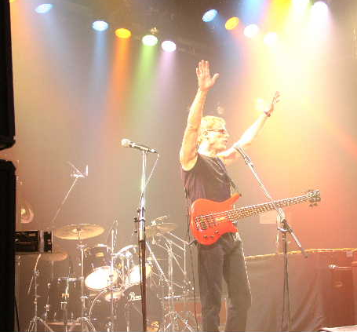

Gongzilla
Journalist Bill Milkowski called GZ “simply mind-boggling”. The group is a mass of contradictions in perfect balance. A band with international roots (USA, Quebec, Philippines); GZ has a reputation for concise songs and transcendent jams. All this emanates from the fusion origins of Bon Lozaga and Hansford Rowe who met while playing in one of the idioms seminal groups – Gong. Bon and Hansford decided to tinker further with the Petri dish that was Gong, and begat a further evolution. They formed Gongzilla and released a series of Mahavishnu-esque improvisational rock albums featuring second guitarists on each one, including jazz fusion legend Allan Holdsworth, David Torn and David Fiuczynski, and a number of drummers, including Pierre Moerlen and Gary Husband.
More recently, Gongzilla has included some U.S. jamband heroes in its live performances like guitarist Chuck Garvey and percussionist Jim Loughlin of moe., and has emphasized vocals, crafting songs which fuse with improvisational rock. Fans who have heard some of the more recent tunes have described them as Steely Dan-ish at times. The new studio record includes the aforementioned Garvey as well as Jake Cinninger of Umphrey's McGee plus guitarist David "Fuze" Fiuczynski (Screaming Headless Torsos) and bassist Kai Eckhardt of Garaj Mahal! Contradictions and balance; Rowe and Lozaga sing cool songs that will singe your soul while balancing both the hyper precision and the rockin’ mayhem this band is capable of live. Gongzilla is currently mixing their 4th studio album for LoLo Records.

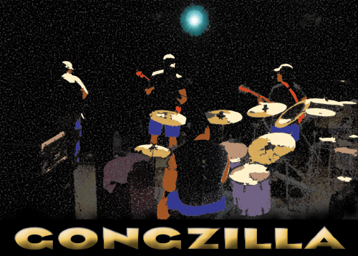 www.myspace.com/gongzilla

Bon Lozaga – guitar, vocals
Hansford Rowe – bass, vocals
Mike Miz – guitar, vocals
Curtis Wingfield - drums

