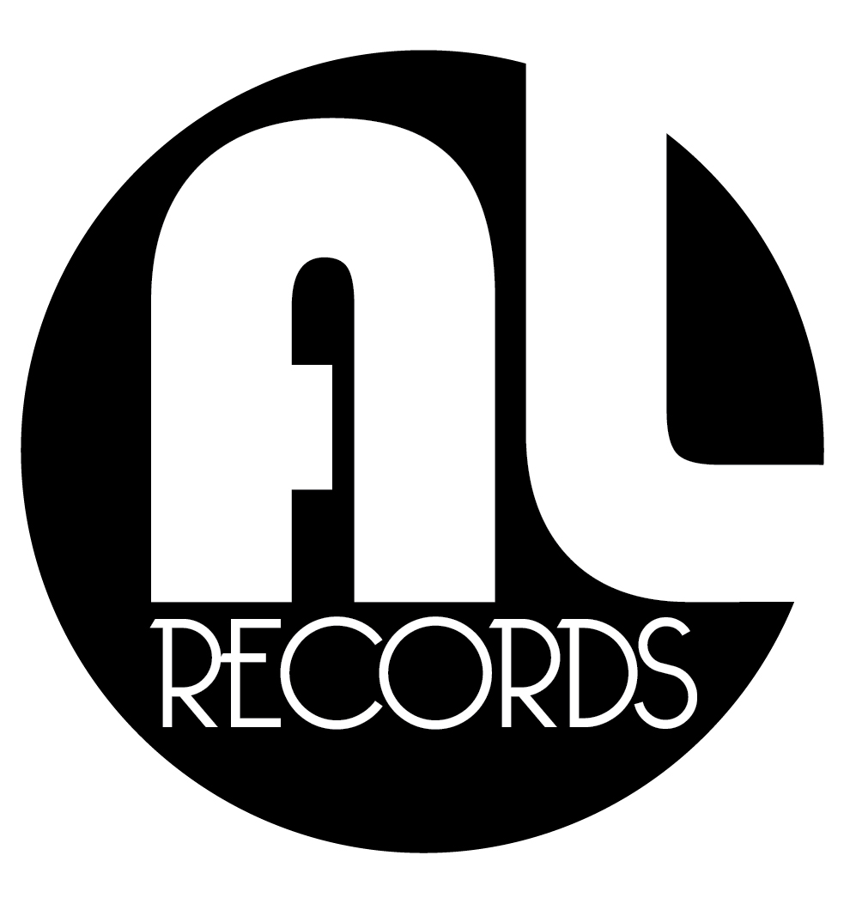 | Music in real time

MOMENT

a moment is all we ever have

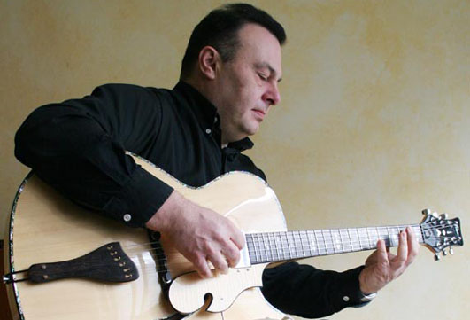
Jordi Torrens is one of the best jazz guitarists Spain has produced. He has toured the world with Latin stars like Moncho, Dyango, Armando Manzanero and Olga Guillot (with Israel Lopez Cachao on bass). He lives in Calella (Barcelona) in his native Catalonia and has strong ties to Argentina. He is sponsored worldwide by Framus Guitars.
Moment EPK MySpace Facebook

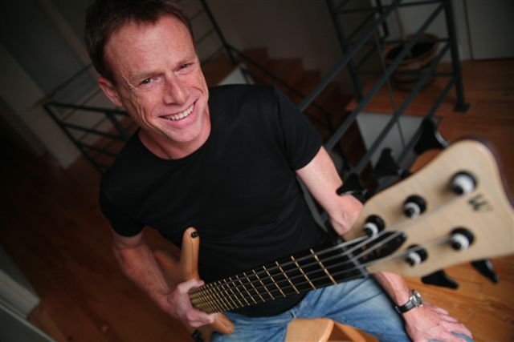
Hansford Rowe began his career in the jazz clubs of New York City. With French drummer Pierre Moerlen he reformed the jazz-rock group PM’s Gong. International touring soon secured Hansford a place among the world's leading bass players and work with Mike Oldfield, Allan Holdsworth, John Martyn, Biréli Lagrène, La Monte Young, David "Fuze" Fiuczynski, Gary Husband, David Torn and many more. He is a founding member of Gongzilla and is sponsored by Warwick Bass Guitars.

Evolution is not linear as paleontologist Stephen Gould often reminded us; shit happens. The very different paths that brought these two musicians together are almost as intriguing as the music they make.

An American bassist/singer from NYC living in Montreal meets a Spanish guitarist from Barcelona in Frankfurt. Worlds collide and the result is a kind of jazz; a strange blend of American and Spanish idioms purified into an organic mix reminiscent of Gilberto/Jobim. Super simple and super sophisticated.

The Paris/Montréal recordings by Denis Savage (Celine Dion) sound so good you'd think heart strings were nylon.

Management N. America
Richard Samson
Tel: 1 (418) 932-7589
Email: rsamson@lappeldularge.com

